**NAME: ASWINI VIJAYAN**

**REG-NO: 720421106301**

**PHASE-II- INNOVATION**

**TRAFFIC MANAGEMENT SYSTEM USING IOT**

**INTRODUCTION :**

Traffic congestion on road networks creates many problems such as increased fuel consumption, increase air pollution, increased queuing of the vehicles and many more. When the number of vehicles exceeds on the road and the traffic controller is not very effective then the traffic congestion occurs. In every cities of India traffic congestion is a major problem which we are facing nowadays. Traffic congestion is caused when the number of vehicle exceeds the available road capacity and second if the proper management is not available. This is known as saturation . Individual incidents such as accidents or sudden braking of a car in a smooth flow of heavy traffic have the highest effects of the slowing speed and cause traffic jams . There are also even a severe many security problems in traffic system in our country due to many elements which also leads to the congestion of traffic at one place. In India, there is an annual loss of Rs 65,000 cores due to traffic congestion which also includes fuel wastage. Congestion in India has also led to slow speeds of freight vehicles, increases fuel consumption, increase air pollution and increased waiting time at checkpoints and toll plazas .As per data the average speed of vehicles on key corridors like Mumbai-Chennai, Delhi-Chennai is less than 30kmph, while there is 22 kmph on Delhi-Mumbai stretch. As per the road corporation of India , India’s freight volume is increasing annually at a rate of 9.08% and that of vehicles at 10.76%, but that of road is only by 4.01%. These all things combined resulted in reduced road space in comparing to the number of total vehicles in the country.

## (Internet of Things)

It refers to a system consisting of inter related internet connected object that are able to collect and transfer data over a wireless network. In this proposed system, it consists of ARDUINO, IR sensor, Wi-Fi modules.

IR sensors will capture the density of each one so the traffic light time will be assigned on the basis of data collected through it.

## SYSTEM DESIGN AND ARCHITECHTURE

### ARDUINO NANO

An 8 bit Microchip AVR which is small, complete and bread board friendly board based on the Atmega328. It is the main CPU of our Project, in which we all the program will run.

**POWER SUPPLY MODULE**

A power supply is a hardware component that provides power to any electrical device.

### IR SENSOR

These sensors are used to detect the object through infrared rays. The rays which are thrown from the sensors are reflected back by the object by which it encountered and then after captured by these infrared sensors which further gets converted into electric signals. These sensors are put sideways for giving us the density of vehicles in the specific lane. Infrared sensors are used for signal control, detection of pedestrians in crosswalks and transmission of traffic information. The basic disadvantages of infrared sensors are that the operation of the system may be affected due to fog; also installation and maintenance of the system is tedious .

**WIFI MODULE**

It is used to give microcontroller access to your wife network.

**RFRX MODULE**

It consists of RF transmitter and RF receiver; it is used for transmitting and receiving data.

**LED**

Light bulbs are used for output and instruction for this system.

### BLYNK APP

It is a mobile application for output and verification for real time data collected.

**BLOCK DIAGRAM**

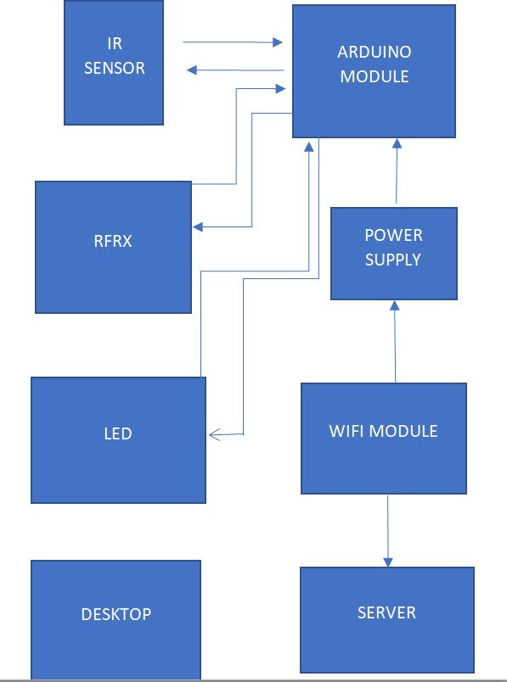

## WORKING PRINCIPLE

There will 8 sensors across the 4 lanes with each lane having 2 sensors each, to give the data how much dense the lane is. If in case the entire lanes have less traffic then the system will work normally means the lanes sequence will be first A lane then B lane, then C lane and at last D lane. But in case if any of the lane gets more cars or gets denser then the other 3 lanes then that specific lane will open then the other with the second highest denser, then the same order continued to the other 2 lanes. If in case all the lanes have same number of vehicles then all the lanes will open in same order i.e. A, B, C, D. If in case there is an emergency vehicle that can be ambulance, fire brigade or an emergency scout team then we have a separate Wi-Fi module through which we can open can lane in which the emergency vehicle is arrived.

**Disadvantages of Existing System :** **Advantages of Proposed System :**

1. Traffic Congestion 1. Minimize number of traffic
2. No means to detect traffic congestion 2. Low budget
3. Number of accidents are more 3. Easy implementation
4. It cannot be remotely controlled 4. It is more efficient
5. It requires more manpower